**Name:** Paul Gerald D. Pare **Q2W1**

**Section:** 9 - Adenine **Date:** 01/04/20

**ACTIVITY 1: ATOMIZED ME!**

DIRECTION**:**  Read the hint below for every number. Write the correct answer on the appropriate blank boxes to complete the whole concept map for this lesson.

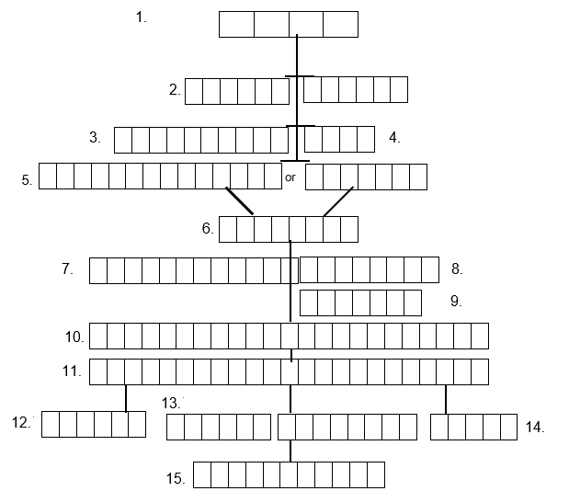

A T O M

M O D E L S

A T O M I C

B O H R

R U T H E R F O R D

Q U A N T U M

E L E C T R O N C L O U D

E L E C T R O N

S U B L E V E L

E N E R G Y L E V E L

O R B I T A L

E L E C T R O N C O N F I G U R A T I O N

A T O M I C O R B I T A L D I A G R A M

P A U L I E X C L U S I O N N

H U N D S

A U F B A U



A T O M I C N U M B E R

**HINT:**

1. From original word ‘Atomos’ which means indestructible & Indivisible.
2. Term used by scientists about the picture explaining atoms and its particles.
3. Model that focuses only on the center of the atom called the Nucleus.
4. More expanded explanation of Electrons and how they move around the nucleus to solve stability problems.
5. Currently the most sophisticated and widely accepted model of the atom.
6. The negative charge particle that moves around outside the nucleus.
7. Are the large regions outside the nucleus.
8. Are smaller regions usually represented by letters.
9. The Smallest region where electrons can really be found, we used box to represent it.
10. It a way to show how electrons are distributed following certain rules.
11. It shows how electrons are arranged per sublevels in an atom.
12. This principle/rule means building up from lowest to highest.
13. This rule said that there must be only 2 electrons that can stay in an orbital.
14. Rule wherein electrons occupy singly first in an orbital before it will be paired with an opposite spin electron.
15. It is also the same as the number of electrons in an atom of an element.

**ACTIVITY 2: COMPLETE ME!**

DIRECTION: Write the missing part in the blank to complete the sentence.

1. Nucleus is the center of the atom mostly responsible for its mass.
2. Energy levels are represented by – Orbital Diagram or 1 - 7 (_-_ )
3. Sublevels are designated as – s, p, d, f (_, _, _, _)
4. The lowest energy level is 1 & the highest is 7.
5. Sharp orbital (s) has 1 orbital & 2 maximum no. of electrons.
6. Principal orbital (p) has 3 orbital & 6 maximum no. of electrons.
7. Diffuse orbital (d) has 5 orbital & 10 maximum no. of electrons.
8. Fundamental orbital (f) has 7 orbital & 14 maximum no. of electrons.
9. Electrons occupy orbital in an upward/building up rule direction.
10. Electrons of one atom can be shared with another atom.

**ACTIVITY 3: ARRANGE ME!**

DIRECTION: Arrange the boxes to form the correct electron distribution pattern/mnemonics following the rules. Write your answer on the blank boxes below. (10 pts)

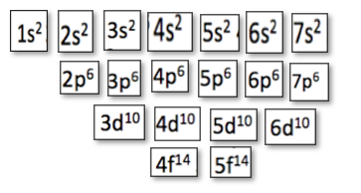

|  |  |  |  |
| --- | --- | --- | --- |
| 1s2 | 2s2 | 2p6 | 3s2 |
| 3p6 | 4s2 | 3d10 | 4p6 |
| 5s2 | 4d10 | 5p6 | 6s2 |
| 4f14 | 5d10 | 6p6 | 7s2 |
| 5f14 | 6d10 | 7p6 |  |

ELECTRON DISTRIBUTION

PATTERN/MNEMONICS